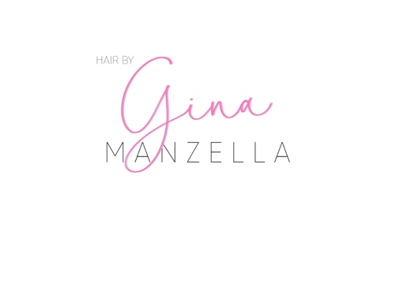

Contract for Installation, Removal, & Maintenance of Tape- In Hair Extensions
I _________________________________ understand and agree to the following terms regarding wearing, removing, and maintaining my Glam Seamless Tape-In Hair Extensions. If I breach this contract in any way, I cannot hold my hair stylist or the hair brand responsible.
My Responsibilities:
- I will not wear my extensions longer than recommended (8-10 weeks).
- I will not try to “fix” my own extensions, or cut them in any way.
- I will not remove my own extensions.
- I will only use the proper Glam Seamless approved Hair Care products for my tape-in hair extensions.
- I will use a hair extension brush to remove any tangles and keep my hair from excess product buildup, excessive moisture, and will use a thermal spray to protect hair. I will sleep with my hair in a loose, low ponytail or braid (Hairstylist or Glam Seamless will not be responsible for loose or slipping extensions because of excess moisture or improper maintenance).
- I will not expose the hair extensions to salt water.
- I will attend all my appointments in regards to the care of my extensions. (Stylist will not be responsible for damage or slipping caused by missing appointments.)
- I will brush hair with brush gently 2-3 times daily.
- I will follow all recommendations by my hairstylist, including when to replace hair extensions that can no longer be used.
- I will not place oils, conditioners, or products with alcohol on or near the tape tabs.
Stylist Responsibilities:
  - Stylist will not perform any same day chemical treatments on the day of installation (Color, Keratin, etc.)
  - Stylist will make sure you understand the entire extensions service, including maintenance.
  - Stylist will not apply extensions to damaged, oily, or hair that is not suitable for tape in hair extensions.
  - Stylist is not responsible for damage to scalp, hair and loss of extensions from improper use or care.
  - Stylist does not color extensions. Color is matched to hair color you currently have at the consultation.
  - Client must notify the stylist within 7 days of your visit to correct any issues. If notified after 7 days a removal fee will be charged.
  - No refunds will be issued
  - Removal and Maintenance will be done by the stylist for an hourly fee.
  - Stylist reserves the right to decline hair extensions services if he or she feels that the hair is being compromised in any way.

Client Signature __________________________ Date________________

